Nebraska continues towards full jobs recovery from pandemic recession
By Michael Lucci, Senior Policy Advisor, Platte Institute

Nebraska gained 400 non-farm payroll jobs in March and its unemployment rate fell from 2.1% to 2.0%, according to new data from the Bureau of Labor Statistics. The low unemployment rate ties Nebraska with Utah as the states with the lowest jobless rates. In addition, Nebraska’s strong February jobs gain was revised slightly upwards, thus adding to the improvement in the Cornhusker State’s recovery.

The Bureau of Labor Statistics’ business establishment survey counts how many non-farm payroll jobs are currently filled in each state. The survey shows that Nebraska has 1,025,400 total non-farm payroll jobs and is closing in on recovering its pre-pandemic jobs peak.

Nebraska lost nearly 100,000 jobs during the pandemic-induced economic plunge from February 2020 – April 2020. During the same time period, the United States as a whole lost 22 million jobs. Though Nebraska experienced a terrible rate of in-state jobs loss, Nebraska’s jobs decline was less severe than the nation’s during the pandemic plunge. Furthermore, Nebraska is on pace to reach a full jobs recovery slightly ahead of the U.S. as a whole.

Nebraska’s jobs count fell from 1,032,800 to 934,600 during the first two months of the pandemic decline, equal to a 9.5% decline in Nebraska’s jobs count. During the same time period, U.S. jobs plunged from 152.5 million to 130.5 million, a 14.4% decline. Thus, Nebraska did a better job than the nation as a whole in preserving jobs during the pandemic plunge.
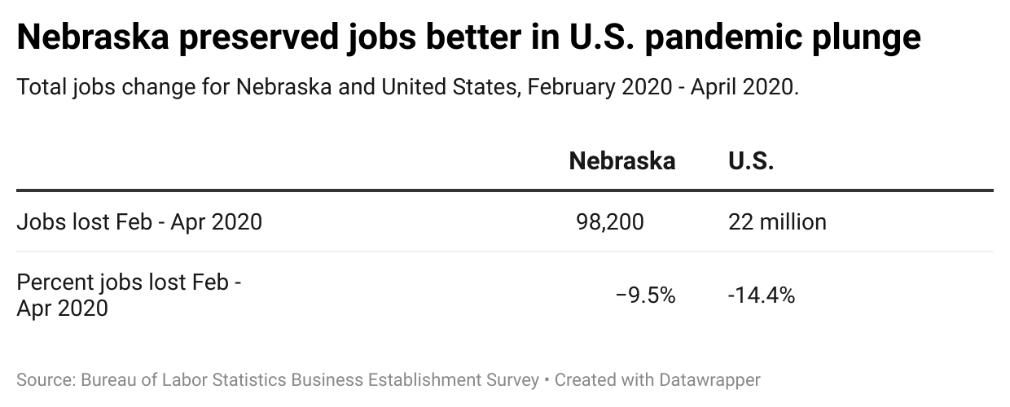

Nebraska’s less-steep plunge is likely attributable to several factors, including industrial makeup, less severe government restrictions, cultural factors, and perhaps even a less dense population concentration. Nebraskans involved in the packing, manufacturing, and shipment of food and energy, for example, provided essential work to keep food on America’s dinner tables during the pandemic. On the other hand, there was scarcely any demand for tourism workers in places like Nevada, Hawaii, and Florida. Indeed, other factors, including government response, likely contributed to Nebraska’s less severe plunge, too.

Nebraska is now only 7,400 jobs away from a full recovery of its pre-pandemic jobs count, which makes it slightly better than the U.S. as a whole. The U.S. is still a full percentage point below its pre-pandemic peak.

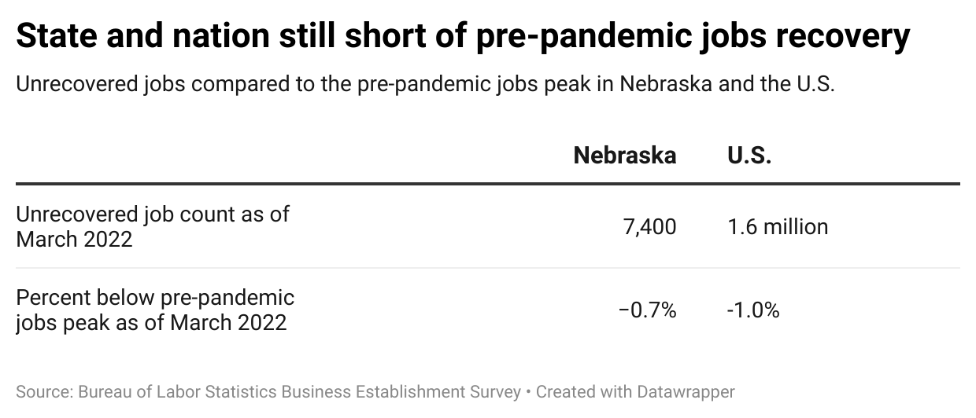

There are 13 states that have surpassed their pre-pandemic jobs peak, including Nebraska’s neighbors South Dakota (11th) and Colorado (12th). Nebraska is currently on pace to finish 18th among states for recovering to its pre-pandemic jobs peak.

The top spots in the state jobs rankings are dominated by Sunbelt and Mountain West states. These states have attractive physical environments and warm climates, and are gaining residents from other states for those reasons. But they are also highly competitive on tax and regulatory policies, too. Indeed, most of the top recovery states applied a lighter touch in pandemic restrictions, and many have recently accomplished tax and spending reforms.

Nebraska reduced its top income tax rates in 2022, which will eventually bring Nebraska closer to the middle of the pack (#28) in rankings for the competitiveness of its tax structure, assuming other states don’t leapfrog Nebraska before its tax changes are fully phased in. Nebraska’s overall tax burden is the highest of neighboring states. Thus, much work remains to make Nebraska’s tax code more competitive. Nebraska can outcompete other states, but it needs to modernize its tax code to do so.

